Central Angle Theorem
# Source: AI Source: Provided by: [Data Path: Persons Table -> ID Column: 1, Name_En Column: Motasem Essam] -> From: [ChatGPT] on [7/25/2026]
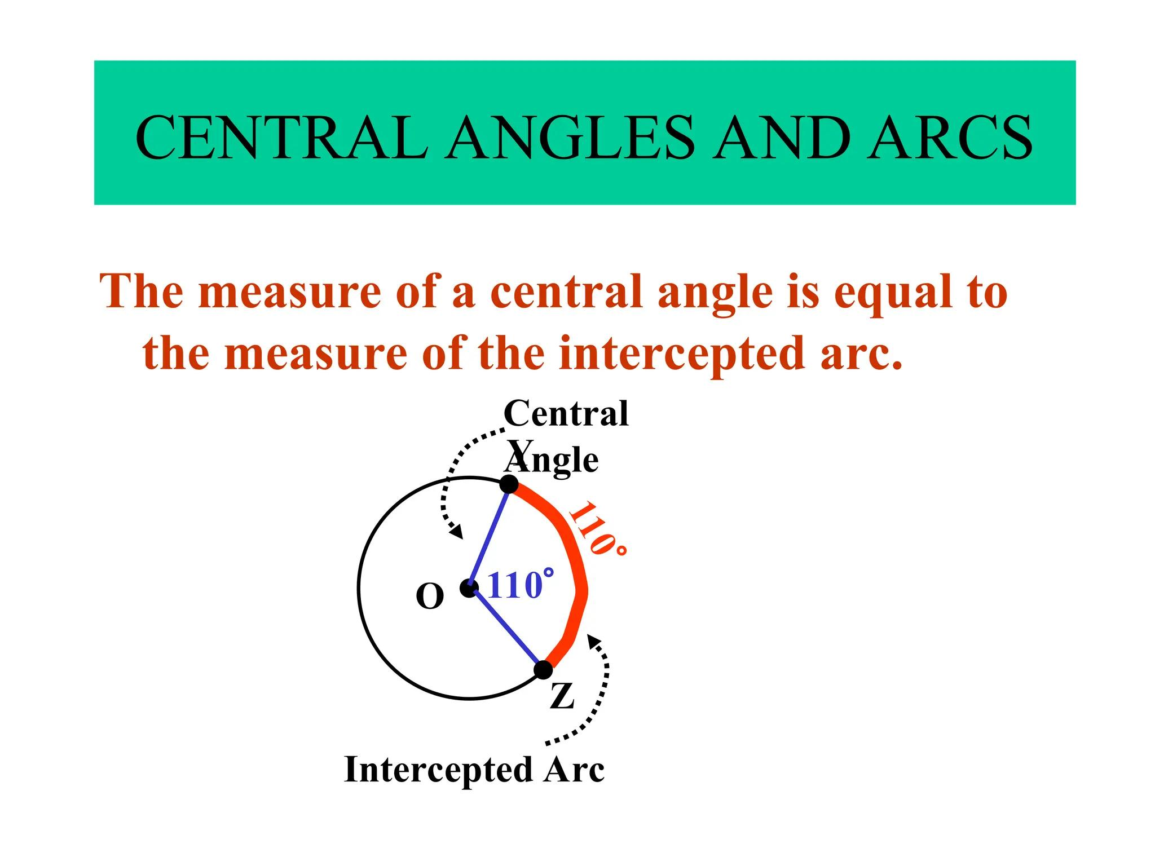
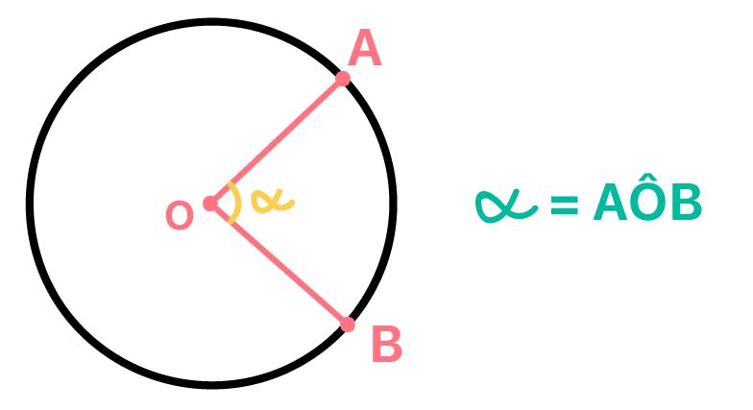
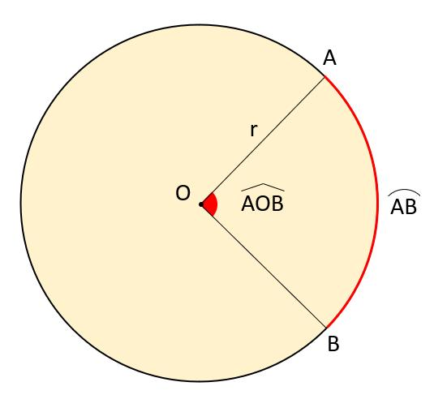
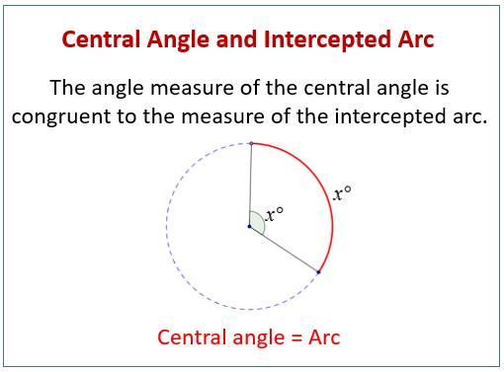

Definition
# Source: AI Source: Provided by: [Data Path: Persons Table -> ID Column: 1, Name_En Column: Motasem Essam] -> From: [ChatGPT] on [7/25/2026]
The Central Angle Theorem states that the measure of a central angle of a circle is equal to the measure of the arc intercepted by that angle.
If $O$is the center of a circle and $∠AOB$is a central angle intercepting arc $\hat{AB}$, then:
$$\boxed{m\left(∠AOB\right)=m\left(\hat{AB}\right)}$$
This theorem is one of the fundamental relationships between angles and arcs in a circle.

Fundamental Concept
# Source: AI Source: Provided by: [Data Path: Persons Table -> ID Column: 1, Name_En Column: Motasem Essam] -> From: [ChatGPT] on [7/25/2026]
A central angle has its vertex at the center of the circle and its sides are radii.
For:
$$∠AOB$$
- $O$is the center.
- $OA$and $OB$are radii.
- $\hat{AB}$is the intercepted arc.
The central angle and its intercepted arc always have the same measure.
$$\boxed{\text{Central Angle Measure}=\text{Intercepted Arc Measure}}$$

Theorem Statement
# Source: AI Source: Provided by: [Data Path: Persons Table -> ID Column: 1, Name_En Column: Motasem Essam] -> From: [ChatGPT] on [7/25/2026]
For a circle with center $O$:
$$\boxed{m\left(∠AOB\right)=m\left(\hat{AB}\right)}$$
For example, if:
$$m\left(∠AOB\right)={70}^{∘}$$
then:
$$\boxed{m\left(\hat{AB}\right)={70}^{∘}}$$
Conversely, if:
$$m\left(\hat{AB}\right)={120}^{∘}$$
then:
$$\boxed{m\left(∠AOB\right)={120}^{∘}}$$

Main Parts
# Source: AI Source: Provided by: [Data Path: Persons Table -> ID Column: 1, Name_En Column: Motasem Essam] -> From: [ChatGPT] on [7/25/2026]
Consider central angle $∠AOB$.
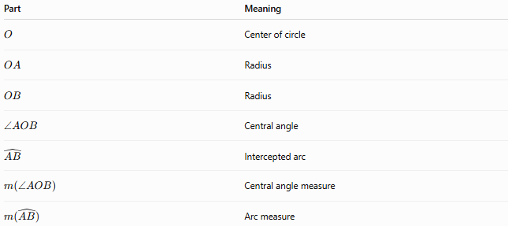
Part | Meaning
$$O$$ | Center of circle
$$OA$$ | Radius
$$OB$$ | Radius
$$∠AOB$$ | Central angle
$$\hat{AB}$$ | Intercepted arc
$$m\left(∠AOB\right)$$ | Central angle measure
$$m\left(\hat{AB}\right)$$ | Arc measure
The essential relationship is:
$$\boxed{m\left(∠AOB\right)=m\left(\hat{AB}\right)}$$

Relationship Between Central Angles and Arcs
# Source: AI Source: Provided by: [Data Path: Persons Table -> ID Column: 1, Name_En Column: Motasem Essam] -> From: [ChatGPT] on [7/25/2026]
A central angle determines an arc.
Small central angle
If:
$$m\left(∠AOB\right)<{180}^{∘}$$
it intercepts a minor arc.
Straight central angle
If:
$$m\left(∠AOB\right)={180}^{∘}$$
it intercepts a semicircular arc.
Reflex central angle
If:
$${180}^{∘}<m\left(∠AOB\right)<{360}^{∘}$$
it intercepts a major arc.
Therefore:
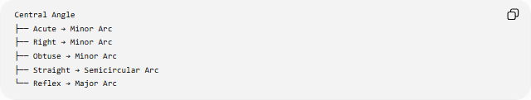
Central Angle
├── Acute → Minor Arc
├── Right → Minor Arc
├── Obtuse → Minor Arc
├── Straight → Semicircular Arc
└── Reflex → Major Arc

Types of Central Angles
# Source: AI Source: Provided by: [Data Path: Persons Table -> ID Column: 1, Name_En Column: Motasem Essam] -> From: [ChatGPT] on [7/25/2026]
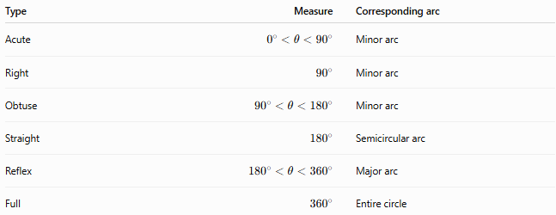
Type | Measure | Corresponding arc
Acute | $$0^{∘}<θ<{90}^{∘}$$ | Minor arc
Right | $${90}^{∘}$$ | Minor arc
Obtuse | $${90}^{∘}<θ<{180}^{∘}$$ | Minor arc
Straight | $${180}^{∘}$$ | Semicircular arc
Reflex | $${180}^{∘}<θ<{360}^{∘}$$ | Major arc
Full | $${360}^{∘}$$ | Entire circle
The arc has the same degree measure as its central angle.

Central Angles Around a Point
# Source: AI Source: Provided by: [Data Path: Persons Table -> ID Column: 1, Name_En Column: Motasem Essam] -> From: [ChatGPT] on [7/25/2026]
All central angles around the center of a circle make one complete rotation:
$$\boxed{{360}^{∘}}$$
Therefore, if several central angles divide a circle:
$$\boxed{θ_{1}+θ_{2}+θ_{3}+⋯+θ_{n}={360}^{∘}}$$
The corresponding arcs also have measures that sum to:
$$\boxed{{360}^{∘}}$$

Equal Central Angles and Equal Arcs
# Source: AI Source: Provided by: [Data Path: Persons Table -> ID Column: 1, Name_En Column: Motasem Essam] -> From: [ChatGPT] on [7/25/2026]
If two central angles in the same circle are equal, their intercepted arcs are equal.
If:
$$m\left(∠AOB\right)=m\left(∠COD\right)$$
then:
$$\boxed{m\left(\hat{AB}\right)=m\left(\hat{CD}\right)}$$
Conversely:
$$m\left(\hat{AB}\right)=m\left(\hat{CD}\right)$$
implies:
$$\boxed{m\left(∠AOB\right)=m\left(∠COD\right)}$$

Central Angle and Arc Length
# Source: AI Source: Provided by: [Data Path: Persons Table -> ID Column: 1, Name_En Column: Motasem Essam] -> From: [ChatGPT] on [7/25/2026]
The Central Angle Theorem gives the angular measure of an arc. That measure can then be used to calculate arc length.
For an angle $θ$measured in degrees:
$$\boxed{L=\frac{θ}{{360}^{∘}}\left(2πr\right)}$$
where:
- $L$= arc length
- $r$= radius
- $θ$= central angle
Example
If:
$$r=6$$
and:
$$θ={60}^{∘}$$
then:
$$L=\frac{{60}^{∘}}{{360}^{∘}}\left(2π⋅6\right) \\ \boxed{L=2π}$$

Central Angle and Sector Area
# Source: AI Source: Provided by: [Data Path: Persons Table -> ID Column: 1, Name_En Column: Motasem Essam] -> From: [ChatGPT] on [7/25/2026]
A central angle also determines the area of its corresponding sector.
For degrees:
$$\boxed{A=\frac{θ}{{360}^{∘}}πr^{2}}$$
Example
Suppose:
$$r=10, θ={90}^{∘}$$
Then:
$$A=\frac{{90}^{∘}}{{360}^{∘}}π{\left(10\right)}^{2} \\ \boxed{A=25π}$$
Thus, a ${90}^{∘}$central angle creates a quarter-circle sector.

Relationship to the Inscribed Angle Theorem
# Source: AI Source: Provided by: [Data Path: Persons Table -> ID Column: 1, Name_En Column: Motasem Essam] -> From: [ChatGPT] on [7/25/2026]
The Central Angle Theorem is directly related to the Inscribed Angle Theorem.
For the same intercepted arc:
$$\boxed{m\left(\text{central angle}\right)=2m\left(\text{inscribed angle}\right)}$$
Therefore:
$$\boxed{m\left(\text{inscribed angle}\right)=\frac{1}{2}m\left(\text{central angle}\right)}$$
Since the central angle equals the intercepted arc:
$$\boxed{m\left(\text{inscribed angle}\right)=\frac{1}{2}m\left(\text{intercepted arc}\right)}$$
Example
If:
$$m\left(∠AOB\right)={100}^{∘}$$
then an inscribed angle intercepting the same arc has measure:
$$\boxed{{50}^{∘}}$$

Example 1 — Finding an Arc
# Source: AI Source: Provided by: [Data Path: Persons Table -> ID Column: 1, Name_En Column: Motasem Essam] -> From: [ChatGPT] on [7/25/2026]
Given:
$$m\left(∠AOB\right)={85}^{∘}$$
Because the angle is central:
$$m\left(\hat{AB}\right)=m\left(∠AOB\right)$$
Therefore:
$$\boxed{m\left(\hat{AB}\right)={85}^{∘}}$$

Example 2 — Finding a Central Angle
# Source: AI Source: Provided by: [Data Path: Persons Table -> ID Column: 1, Name_En Column: Motasem Essam] -> From: [ChatGPT] on [7/25/2026]
Suppose:
$$m\left(\hat{CD}\right)={140}^{∘}$$
The central angle intercepting this arc must have the same measure:
$$\boxed{m\left(∠COD\right)={140}^{∘}}$$

Example 3 — Finding a Missing Central Angle
# Source: AI Source: Provided by: [Data Path: Persons Table -> ID Column: 1, Name_En Column: Motasem Essam] -> From: [ChatGPT] on [7/25/2026]
Suppose three central angles are:
$${80}^{∘}, {110}^{∘}, {70}^{∘}$$
and the fourth central angle is $x$.
Since all central angles sum to ${360}^{∘}$:
$${80}^{∘}+{110}^{∘}+{70}^{∘}+x={360}^{∘} \\ {260}^{∘}+x={360}^{∘} \\ \boxed{x={100}^{∘}}$$
The corresponding fourth arc is therefore also:
$$\boxed{{100}^{∘}}$$

Special Case — Diameter
# Source: AI Source: Provided by: [Data Path: Persons Table -> ID Column: 1, Name_En Column: Motasem Essam] -> From: [ChatGPT] on [7/25/2026]
A diameter divides a circle into two semicircles.
The corresponding central angle is:
$$\boxed{{180}^{∘}}$$
Therefore:
$$\boxed{m\left(\text{semicircular arc}\right)={180}^{∘}}$$
This is a direct application of the Central Angle Theorem.

Central Angle vs. Inscribed Angle
# Source: AI Source: Provided by: [Data Path: Persons Table -> ID Column: 1, Name_En Column: Motasem Essam] -> From: [ChatGPT] on [7/25/2026]
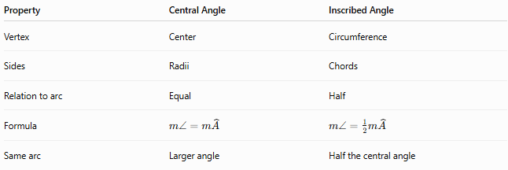
Property | Central Angle | Inscribed Angle
Vertex | Center | Circumference
Sides | Radii | Chords
Relation to arc | Equal | Half
Formula | $$m∠=m\hat{A}$$ | $$m∠=\frac{1}{2}m\hat{A}$$
Same arc | Larger angle | Half the central angle

Central Angle vs. Arc
# Source: AI Source: Provided by: [Data Path: Persons Table -> ID Column: 1, Name_En Column: Motasem Essam] -> From: [ChatGPT] on [7/25/2026]
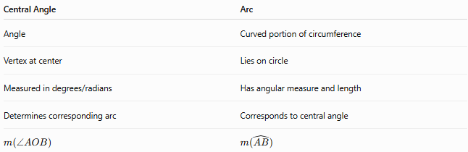
Central Angle | Arc
Angle | Curved portion of circumference
Vertex at center | Lies on circle
Measured in degrees/radians | Has angular measure and length
Determines corresponding arc | Corresponds to central angle
$$m\left(∠AOB\right)$$ | $$m\left(\hat{AB}\right)$$
The Central Angle Theorem connects them:
$$\boxed{m\left(∠AOB\right)=m\left(\hat{AB}\right)}$$

Important Properties
# Source: AI Source: Provided by: [Data Path: Persons Table -> ID Column: 1, Name_En Column: Motasem Essam] -> From: [ChatGPT] on [7/25/2026]
- The vertex of a central angle is the center of the circle.
- The sides of a central angle are radii.
- A central angle and its intercepted arc have equal degree measures.
- Central angles around the center sum to:
$$\boxed{{360}^{∘}}$$
- Equal central angles intercept equal arcs.
- Equal arcs subtend equal central angles.
- A ${180}^{∘}$central angle intercepts a semicircular arc.
- A ${360}^{∘}$central angle represents the complete circle.
- A central angle is twice an inscribed angle intercepting the same arc.

Applications
# Source: AI Source: Provided by: [Data Path: Persons Table -> ID Column: 1, Name_En Column: Motasem Essam] -> From: [ChatGPT] on [7/25/2026]
The Central Angle Theorem is used in:
- Circle geometry
- Arc measurement
- Arc length
- Sector area
- Inscribed angle problems
- Circle constructions
- Regular polygons
- Coordinate geometry
- Engineering and CAD
- Computer graphics

Key Formula Summary
# Source: AI Source: Provided by: [Data Path: Persons Table -> ID Column: 1, Name_En Column: Motasem Essam] -> From: [ChatGPT] on [7/25/2026]
Central angle and arc
$$\boxed{m\left(∠AOB\right)=m\left(\hat{AB}\right)}$$
Central angles around a circle
$$\boxed{\sum{θ}={360}^{∘}}$$
Arc length
$$\boxed{L=\frac{θ}{{360}^{∘}}\left(2πr\right)}$$
Sector area
$$\boxed{A=\frac{θ}{{360}^{∘}}πr^{2}}$$
Central angle and inscribed angle
$$\boxed{m\left(\text{central angle}\right)=2m\left(\text{inscribed angle}\right)}$$

Conclusion
# Source: AI Source: Provided by: [Data Path: Persons Table -> ID Column: 1, Name_En Column: Motasem Essam] -> From: [ChatGPT] on [7/25/2026]
The Central Angle Theorem establishes the fundamental relationship between a central angle and its intercepted arc:
$$\boxed{m\left(∠AOB\right)=m\left(\hat{AB}\right)}$$
Because the central angle and arc have equal measures, knowing one immediately determines the other. This relationship also provides the foundation for calculating arc lengths, sector areas, and inscribed angles, making it one of the central theorems of circle geometry.

